Laboratory 13 Report - Heat Treatment and Equipment
Business, Society and Technology  IFE, 3rd semester | LAB REPORT  MANUFACTURING

Lab no. 13 | Title: Heat Treatment and Equipment
Date of lab: 11/12/2025

No. | SURNAME Name | Album No. | Lab group
1. | KOTOWICZ Stanisław | 257100 | BST_en_1

INTRODUCTION
Heat treatment is the controlled heating and cooling of metals to alter their physical and mechanical properties without changing the product shape. The main objectives of heat treatment are to improve hardness, strength, toughness, and ductility of materials. The process consists of three main stages: heating to the required temperature, soaking (holding at temperature), and cooling at a controlled rate. Heat treatment can be performed in various environments including inert gas, air, or vacuum.
Thermochemical treatments are processes that modify both the chemical composition and microstructure of the surface layer. Common thermochemical treatments include annealing, normalizing, hardening, and tempering. More specialized processes such as carburizing, nitriding, and sulphonitriding are used to create hard, wear-resistant surface layers while maintaining a tough core.

TASK 1: Vacuum Carburizing Equipment (VPT Furnace)

Principle of Operation
Carburizing is a thermochemical case-hardening process in which carbon is diffused into the surface of low-carbon steel at elevated temperatures (850–1050°C for most steels, up to 1200°C for high-speed tool steels). The process is performed in a carbon-rich environment under vacuum (approximately 10 Pa), using gases such as acetylene (C₂H₂) or ethylene (C₂H₄) mixed with a carrier gas. The vacuum environment eliminates surface oxidation and decarburization, producing clean parts that require minimal post-treatment finishing.
Vacuum carburizing is performed by introducing carbon-containing gases in pulses (VPT — Vacuum Pulse Technology), allowing precise control of carbon potential and uniform distribution across complex geometries. After carburizing, the parts are quenched with pressurized nitrogen for rapid cooling, achieving the desired martensitic microstructure. Optionally, tempering follows to reduce internal stresses and enhance toughness. The resulting surface hardness can reach approximately 800 HV while maintaining a ductile core.

Construction of the VPT Furnace
The VPT furnace observed in the laboratory is designed with a sealed, high-strength chamber capable of maintaining low pressure for vacuum operations. It features graphite heating elements ensuring uniform heat distribution. The furnace includes a vacuum pump system to achieve the required pressure levels and a gas quenching mechanism with high-pressure nitrogen for controlled cooling. Insulation materials line the chamber to minimize heat loss, while an automated control system with an operator panel ensures precise temperature and pressure adjustments for consistent results.

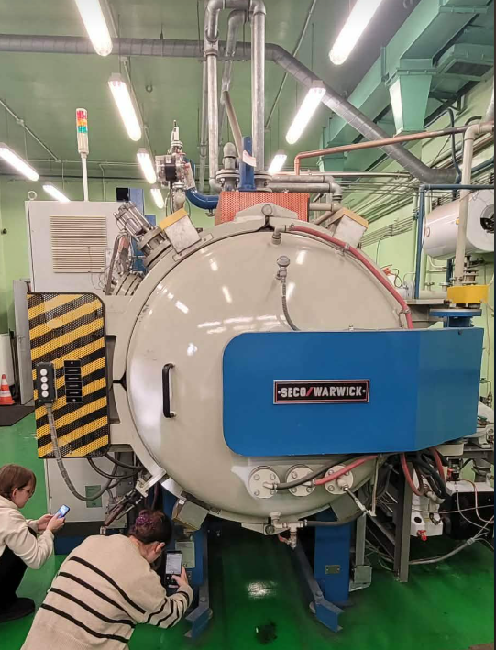
Figure 1. VPT vacuum carburizing furnace — external view.

Technical Parameters of the VPT Furnace
Parameter | Value
Maximum heating temperature | 1300°C
Power supply | 3 × 400 V, 50 Hz
Installed power | 100 kVA
Maximum nitrogen pressure | 12 bar
Maximum hydrogen/helium pressure | 15 bar
Total weight of furnace | 5500 kg
Maximum charge (batch) weight | 200 kg
Maximum workpiece size | 600 × 400 × 400 mm
Loading method | Forklift

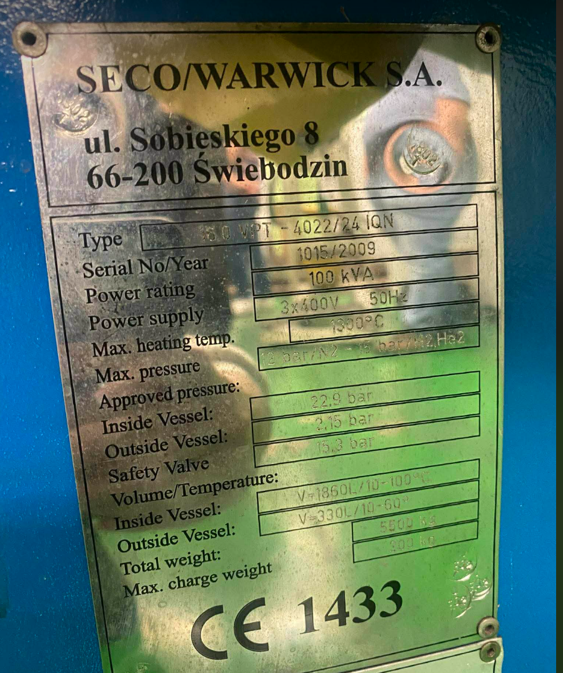
Figure 2. Rating plate of the VPT furnace showing technical specifications.

Workpiece Preparation
Before carburizing, workpieces must be thoroughly cleaned using an ultrasonic cleaner with solvents such as alcohol or acetone to remove contaminants like oil and grease. This prevents impurities from interfering with the carburizing process. The gas mixer precisely combines and regulates the flow of carburizing gases (acetylene or ethylene) to maintain the optimal carburizing environment inside the chamber.
Once cleaned, the workpiece is loaded into the furnace chamber using a forklift. The chamber is then sealed and evacuated to create a vacuum by removing oxygen particles. The vacuum carburizing process then proceeds in the following steps:
- Element Heating: The workpiece is gradually heated to the target temperature (900–1050°C for most steels) at a rate of 2–10°C per minute. The total heating phase typically lasts around 20 hours.
- Carbon Introduction: Carburizing gases (acetylene or ethylene) are introduced in pulses, releasing atomic carbon that diffuses into the steel surface. Solid carbon deposition is avoided to ensure uninterrupted diffusion.
- Carbon Diffusion: Atomic carbon penetrates the surface and diffuses throughout the workpiece. These carburization and diffusion steps are repeated as needed to achieve the desired carbon profile and case depth.
- Quenching: The workpiece is rapidly cooled with pressurized nitrogen to achieve the desired martensitic microstructure.
- Tempering (optional): Subsequent tempering reduces internal stresses and enhances toughness of the hardened layer.

TASK 2: Low-Pressure Nitriding Equipment (Ammonia Gas Nitriding Furnace)

Principle of Operation
Low-pressure nitriding (also referred to as the Nitrovac method) is a thermochemical treatment performed at temperatures of 450–600°C, which is below the tempering temperature of most steels. Ammonia (NH₃) is used as the primary nitrogen source — it dissociates at the heated steel surface (above 450°C), releasing active (nascent) nitrogen atoms and hydrogen. The nitrogen atoms diffuse into the material and react with alloying elements (such as chromium, molybdenum, aluminum) to form hard nitride compounds. The resulting nitrided layer can achieve hardness up to 1200 HV. Due to the low treatment temperature, distortion is minimized and no subsequent quenching or heat treatment is needed.

Construction of the Nitriding Furnace
The ammonia gas nitriding furnace observed in the laboratory consists of a hermetically sealed retort chamber that isolates the workpiece from atmospheric conditions. The furnace includes two chambers: one for heating the workpiece and another for cooling it, which enables continuous operation. A sulphur evaporator is an optional feature for further surface treatment (sulphonitriding), converting solid sulphur into vapor at approximately 160°C to enhance surface properties. Sensors monitor the dissociation rate of ammonia and the nitriding potential, allowing adjustments to achieve the desired microstructure and layer composition.
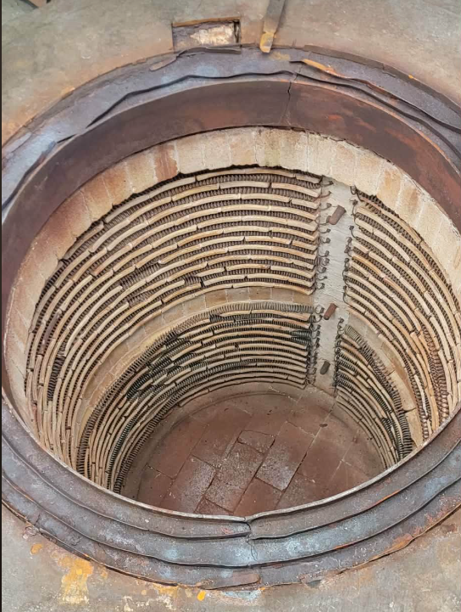
Figure 3. Ammonia gas nitriding furnace — external view.
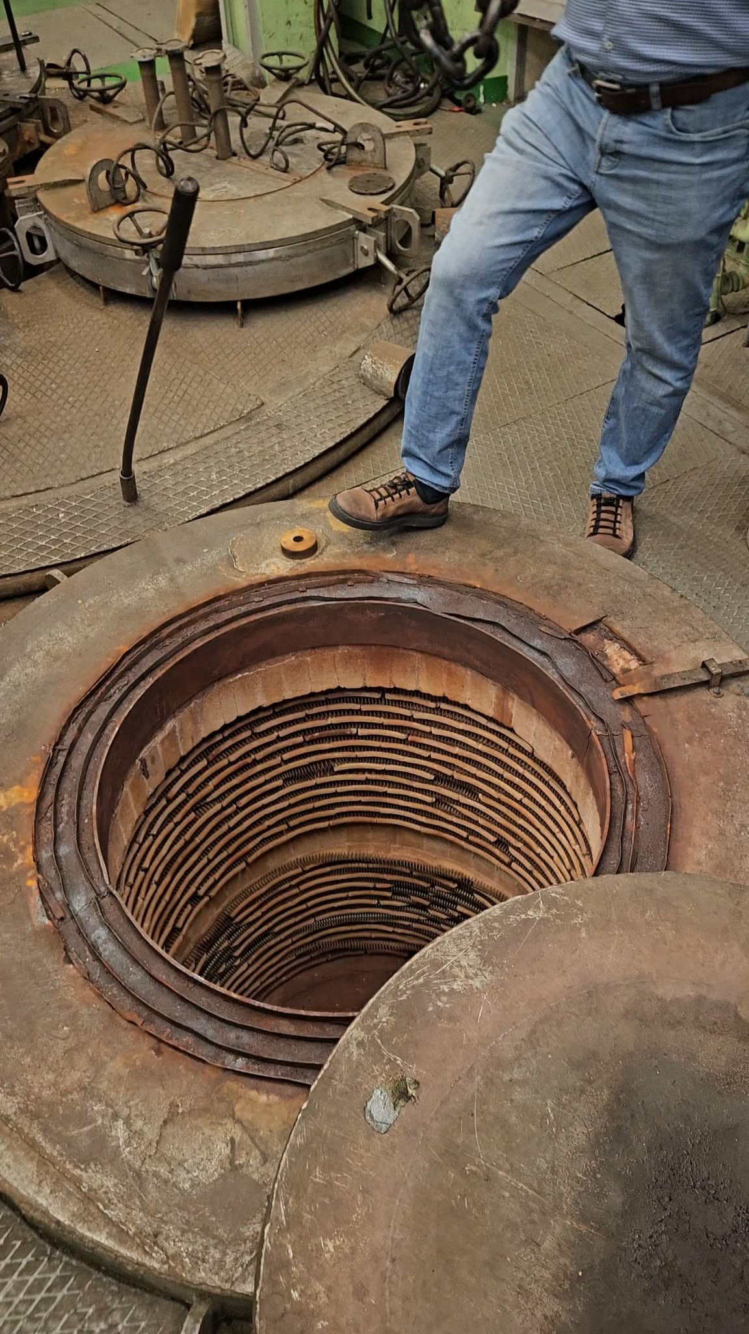
Figure 4. Nitriding furnace chambers — heating chamber (up) and cooling chamber (down).

Workpiece Preparation and Process Steps
Before nitriding, steel components are tempered to stabilize their microstructure. The workpieces are placed into charging baskets and loaded into the retort chamber. The nitriding process then proceeds as follows:
- Heating: The workpiece is heated to the desired nitriding temperature (typically around 550°C) inside the sealed retort.
- Ammonia Dissociation: Ammonia gas is introduced and decomposes at the heated surface into active nitrogen and hydrogen atoms.
- Absorption and Nitriding: Active nitrogen atoms diffuse into the steel surface and form hard nitride compounds with alloying elements, creating a wear-resistant diffusion zone and compound layer.
The nitriding atmosphere is carefully managed to maintain optimal thermodynamic conditions. Advanced control systems monitor and adjust the ammonia dissociation rate and nitriding potential to produce consistent results. Nitriding is widely used for components such as gears, shafts, and cutting tools due to its ability to greatly enhance surface hardness without causing significant dimensional distortion.
[Insert photo of nitriding workpiece charging basket]
Figure 7. Charging basket used for loading workpieces into the nitriding furnace.

TASK 3: HSMG Graphene Production Unit

Principle of Operation
High Strength Metallurgical Graphene (HSMG®) is a new type of graphene material characterized by increased durability and fewer defects compared to conventional CVD graphene. The HSMG production unit operates on the principle of graphene synthesis using a liquid metallic catalyst (typically copper). During the process, carbon atoms from a carburizing gas mixture are adsorbed and incorporated into the liquid copper matrix. The liquid state of copper allows it to become supersaturated with carbon atoms, which promotes the growth of a uniform graphene layer on its surface. This method minimizes defects such as overlapping and grain disorientation, enabling the production of highly durable, continuous graphene sheets with single grains up to 1 mm in size.

Construction of the HSMG Production Furnace
The HSMG production furnace observed in the laboratory includes a heating chamber capable of maintaining temperatures above the melting point of copper (above 1085°C), a controlled gas injection system for introducing the carburizing gas mixture, and precise temperature and pressure sensors. These sensors are critical for maintaining the optimal conditions for carbon saturation and graphene formation. Control methods rely on automated digital systems to regulate temperature, gas flow, and the duration of the carburization process, ensuring consistency and minimizing errors during production.

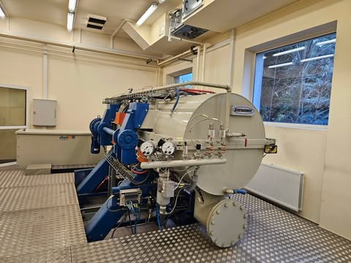
Figure 5. HSMG® graphene production unit.

Properties and Applications
HSMG® graphene has semiconductor properties similar to theoretical graphene. It is manufactured using a patented metallurgical growth process on a liquid metal catalyst. The technology enables mass production and industrial-scale use of graphene, with maximum sheet dimensions reaching up to 100 × 20 cm. Graphene has the thickness of only one atom (approximately 0.34 nm), making it the thinnest known material while possessing extraordinary mechanical strength (approximately 200 times stronger than steel), excellent conductivity, and flexibility.
Applications of HSMG graphene include: construction materials, sensors, touch screens and panels, electronics, composites, space industry components, filtration membranes, energy storage devices, and sports equipment.

CONCLUSIONS
This laboratory visit to the hardening plant provided an overview of modern heat treatment equipment and processes, as well as an emerging materials technology. Three main systems were observed and studied:
- VPT Vacuum Carburizing Furnace: A high-capacity furnace (100 kVA, max charge 200 kg) capable of temperatures up to 1300°C. Vacuum pulse technology enables precise carbon diffusion for surface hardness up to approximately 800 HV, while the vacuum environment eliminates oxidation and produces clean, high-quality parts.
- Low-Pressure Ammonia Gas Nitriding Furnace: A two-chamber retort system operating at 450–600°C. By dissociating ammonia, active nitrogen atoms diffuse into steel surfaces to achieve hardness up to 1200 HV with minimal distortion, eliminating the need for subsequent quenching.
- HSMG® Graphene Production Unit: An innovative furnace that synthesizes graphene on a liquid copper catalyst. The technology produces large, defect-free graphene sheets (up to 100 × 20 cm) with superior mechanical and semiconductor properties, demonstrating potential for wide industrial application.
Overall, the practical observation of these installations highlighted the significance of precise process control — in temperature, pressure, atmosphere composition, and timing — for producing durable, high-performance materials tailored to specific industrial requirements. The equipment observed demonstrated the close relationship between furnace design, process parameters, and the final properties achieved in the treated workpieces.

